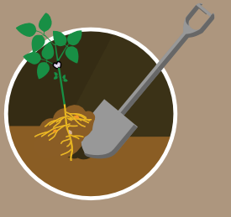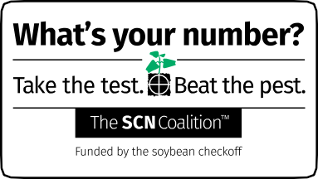
TWO WAYS to scout for SCN.
1 for females. (Dig, don’t pull.)
Dig roots and look
2 samples for testing.
Collect soil
THREE APPROACHES to collecting soil samples.
SCOUTING AND SOIL TESTING FOR SOYBEAN CYST NEMATODE.
Collect 15–20 (or more) 1-inch-diameter core samples, 8 inches deep, for every 20 acres. Mix the cores well, put the mixed soil into a soil sample bag, and send it to an SCN testing lab.
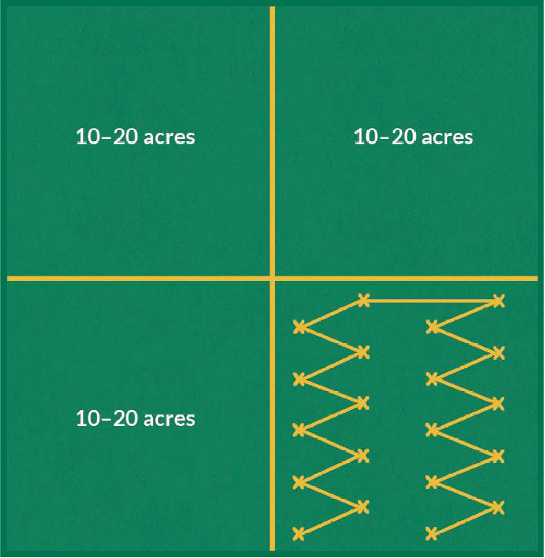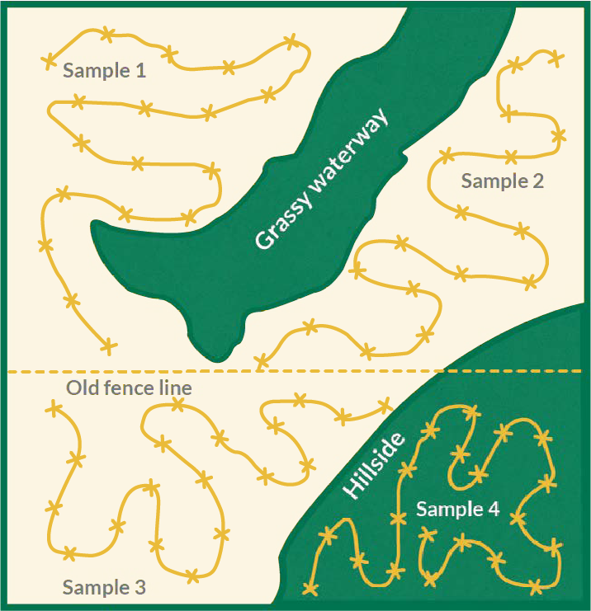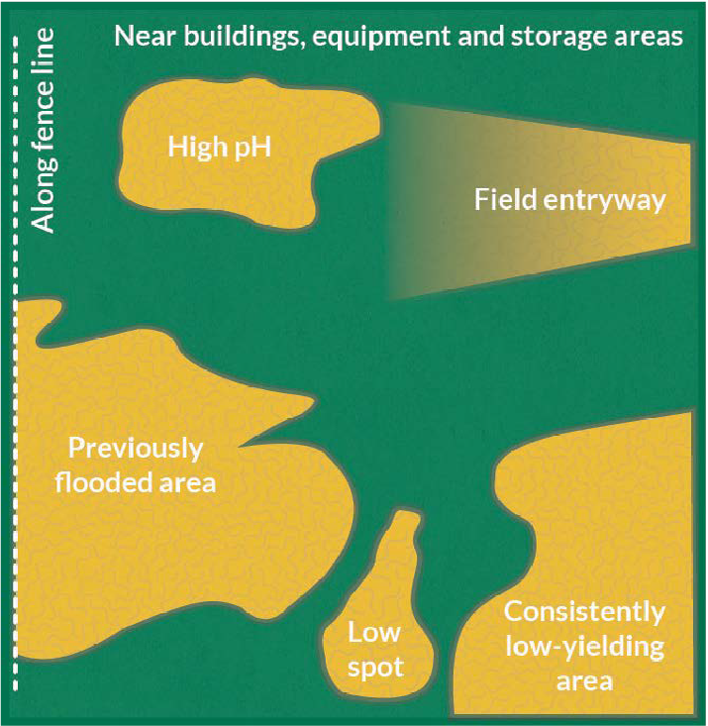

Collect soil cores using a zigzag pattern.
1
2

Collect soil cores from logical areas or management zones in

3Collect soil cores from high-risk

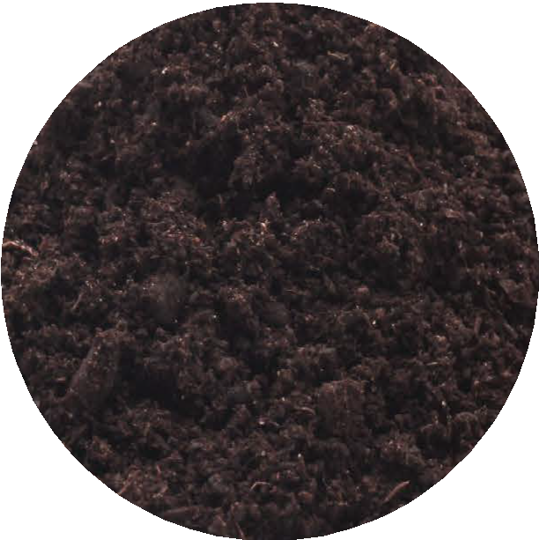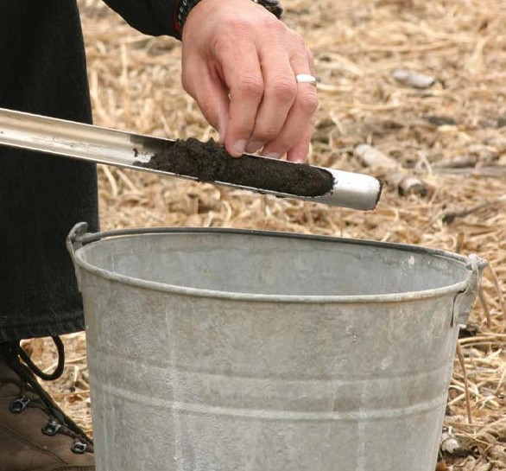WHEN to sample.
0 SCN cysts
egg count = 0
7 SCN cysts
egg count = 1,500
B
A
WHY SCN SOIL TEST results are variable.
It all depends on where you put the probe. A ½-inch difference can mean the difference between zero and 1,500 eggs. (Each cyst can hold 200 to 250 eggs.)
Fall in a non-host crop. Fall in soybean stubble.
Spring before a soybean crop.
During the season in the soybean crop root zone .

Visit TheSCNcoalition.com for more information.

The Mississippi State University Extension Plant Diagnostic Lab is offering free
nematode testing for Mississippi grown soybeans.

To participate, go to extension.msstate.edu/lab to download the Soybean Cyst Nematode Sample Submission Form. Instructions for proper sample collection can be found on the reverse side of this flyer.

Samples must be submitted with the Soybean Cyst Nematode Sample Submission Form by August 30, 2021, to qualify.

Mississippi State University is an equal opportunity institution. Discrimination in university employment, programs, or activities based on race, color, ethnicity, sex, pregnancy, religion, national origin, disability, age, sexual orientation, genetic information, status as a U.S. veteran, or any other status protected by applicable law is prohibited. Questions about equal opportunity programs or compliance should be directed to the Office of Compliance and Integrity, 56 Morgan Avenue, P.O. 6044, Mississippi State, MS 39762, (662) 325-5839.

Extension Service of Mississippi State University, cooperating with U.S. Department of Agriculture. Published in furtherance of Acts of Congress, May 8 and June 30, 1914. GARY B. JACKSON, Director

