Crossbreeding Systems for Beef Cattle

Breeding and genetic management is an essential part of operational decision making, with decisions notably impacting profitability. Commercial cattle producers face input cost management decisions every year. Likewise, they must decide on practices that affect productivity and returns. A well designed and implemented crossbreeding system in commercial cattle operations is one proven way to increase productivity and, ultimately, profitability.

Why Crossbreed?
There are two primary advantages to crossbreeding.
First is the ability to combine traits from two or more breeds into one animal. This is called breed complementary. The second advantage is hybrid vigor,
also known as heterosis, resulting from crossing animals of different breeds.
Breed complementary results when crossbred animals exhibit desirable characteristics from each parent’s breed, resulting in a more valuable animal. This phenomenon allows a breeder to blend the superior traits of one animal with the superior traits of another animal into their crossbred offspring. For example, Zebu cattle are known
for adaptability to hot and humid climates, whereas British cattle are known for superior maternal traits. When crossed, Brahman × British cattle produced from this mating are generally expected to be maternal animals adapted to hot and humid climates. Similarly, Continental breeds would typically inject additional growth performance into a mating with Zebu or British breeds. Mating animals of different breed backgrounds can enhance carcass traits, growth rates, and reproductive performance.
Hybrid vigor, or heterosis, is the increased production of certain traits from the crossing of genetically different individuals. The offspring exceed the average performance of their parents for traits for which hybrid vigor is expressed. For example, Breed A averages 610 pounds at weaning, and Breed B averages 590 pounds at weaning. When crossed, the A × B calves average 625 pounds
at weaning. The hybrid vigor from this mating can be calculated with the following equation:

Hybrid vigor =

(Crossbred performance average – Straightbred performance average) Straightbred performance average

= % Improvement

Inserting the numbers from the example:

Hybrid vigor = (625 – 600) = 4%
600

The hybrid vigor for this cross is 4 percent above the average of the parent breeds for weaning weights. This
is known as individual heterosis. Individual heterosis is the increase in production seen in the crossbred offspring. This type of heterosis is generally seen in growth traits
of the crossbred offspring. Throughout this publication,
% heterosis will be in reference to an F1 (first-generation cross) with 100 percent heterosis.
Another type of heterosis is known as maternal heterosis. Maternal heterosis is the increase in average production observed in crossbred females compared to straightbred females. It is often noted in increased calving percentages, higher weaning weights, greater longevity
in the dam, and other reproductive traits. Enhanced production from the crossbred female is the primary benefit from a planned crossbreeding system. Therefore, it makes sense to cross a straightbred bull on crossbred females to take advantage of maternal heterosis instead of the reverse.

Crossbreeding Systems
A successful crossbreeding system enhances
production through individual and/or maternal heterosis while also using additional labor and facilities required
for implementing the system in a cost-effective manner. Before implementing a crossbreeding program, a producer needs to have well-defined goals for the operation. Several questions need to be asked. Will calves be marketed as feeder calves, or will ownership be retained through stockering and/or finishing? Will replacement heifers be purchased or raised? What marketing channel will be used

to sell cattle, and what value does it place on various traits? The answers to these questions will impact the type of crossbreeding system that best fits with operational goals.
A variety of crossbreeding systems are available for breeders to use in their genetic improvement programs. These systems vary in the direct and maternal hybrid vigor they produce, the number of breeding pastures they require, the number of breeds used, optimal practical herd size, whether or not replacement females are produced or purchased, labor and management requirements, and timing of herd sire
purchases. Therefore, it is important to weigh all of these considerations before selecting the most appropriate crossbreeding system for a commercial herd.

Two-breed Terminal
The two-breed terminal system is the most basic crossbreeding system available (Figure 1). This system crosses Breed A females with Breed T sires to produce a crossbred animal that is half Breed A and half Breed T and known as an F1. All of the offspring from this initial cross are marketed, and replacement heifers are purchased.

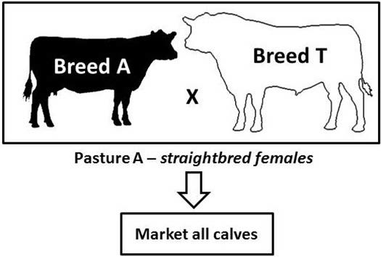

Figure 1. Two-breed terminal crossbreeding system.

The two-breed system is fairly simplistic. Only one breeding pasture is needed, labor and management are minimized, and progeny produced are highly uniform and marketable. Replacement heifers are purchased, which frees up labor, land, and other resources to be dedicated
to other aspects of production. This system is often used to produce F1 replacement heifers to be sold as breeding females to other operations. This program is appropriate for herds of all sizes because only one sire breed is used, just one breeding pasture is needed, and replacement females are purchased.
Before using this type of system, a producer needs to consider that no maternal heterosis will result from using straightbred females. This will result in lower production per breeding female than will be seen in crossbred females because 0 percent maternal heterosis results
from the straightbred females. However, 100 percent individual heterosis is realized, which results in a slight increase in average weaning weight per cow exposed. In addition, one must consider the source and availability of replacement heifers.

Three-breed Terminal
The three-breed terminal system is identical to the two-breed terminal system except that the females are crossbred females A × B mated to sires of Breed T (Figure
2). This terminal system has many advantages. Only one breeding pasture is needed, and sire identification of breeding females is easily recognized. Replacement females are purchased, and all calves are marketed. Because replacement heifers are not being produced, sires can be chosen only on growth and carcass with no
attention to maternal traits. The terminal system works for herds of all sizes. The three-breed terminal system results in the most hybrid vigor of any crossbreeding scheme.
This system results in 100 percent of both individual and maternal heterosis over the average of the parent breeds, which results in an increase of 24 percent in pounds of calf weaned per cow exposed.

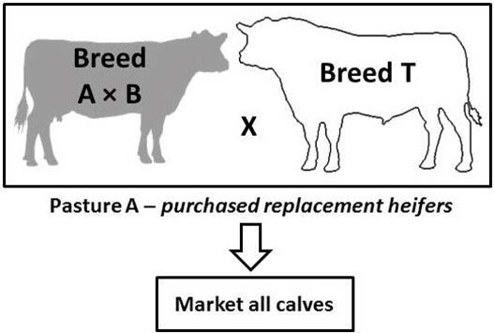

Figure 2. Three-breed terminal crossbreeding system.

Because replacement heifers are purchased, a source of quality crossbred females is essential. To maintain uniformity in progeny, replacements purchased should be similar to females in the breeding herd. Replacement females should be environmentally adapted with the
necessary maternal capacities. Age of replacements should also be a consideration. If yearling heifers are purchased, a separate calving ease bull must be maintained to breed to them, complicating the system. It is generally recommended to purchase bred heifers or cows so that the same herd sire(s) can be used for all breeding females. In addition to source, cost of replacement heifers needs to be evaluated. In this system, quality crossbred females are always in demand and highly valued. In order to use this system, a manager must determine what the operation can afford to spend on these replacement females.

Two-breed Rotation
The two-breed rotation is an effective and relatively simple crossbreeding system that takes advantage of individual and maternal heterosis (Figure 3). In this system, females sired by Breed A are mated to sires of Breed B, and females sired by Breed B are mated to sires of Breed A. This system requires two breeding pastures and identification
of sire for each breeding female. Identification is easily accomplished with an ear-tagging system with color representing breed of sire. Replacement heifers sired by Breeds A and B are retained. After several generations of using this cross, hybrid vigor will stabilize at 67 percent of potential individual and direct heterosis with an expected 16 percent increase in pounds of calf weaned.
Considerations when using the two-breed rotation are breed type, resources available to raise replacement heifers, and size of cowherd. Biological type is significant because females are being retained that are sired by
both Breeds A and B. Both breeds should have maternal characteristics conducive to use as commercial females. Also, replacement heifers are retained in this system, which requires additional land, labor, and resources. Cost and availability of these resources need to be considered.
The last consideration is size of cowherd. The two- breed rotation requires at least one bull from each breed. Assuming each bull is used to service 25 females annually, a herd will need at least 50 breeding-age females for the system to be efficient. The two-breed rotation can be used with fewer cows; however, bull expenses per cow will be greater.

Three-breed Rotation
The three-breed rotation is very similar to the two- breed rotation with another breed added. This rotation uses sires of Breeds A, B, and C. Breed A sires are mated to females sired by Breed B, Breed B sires are mated to

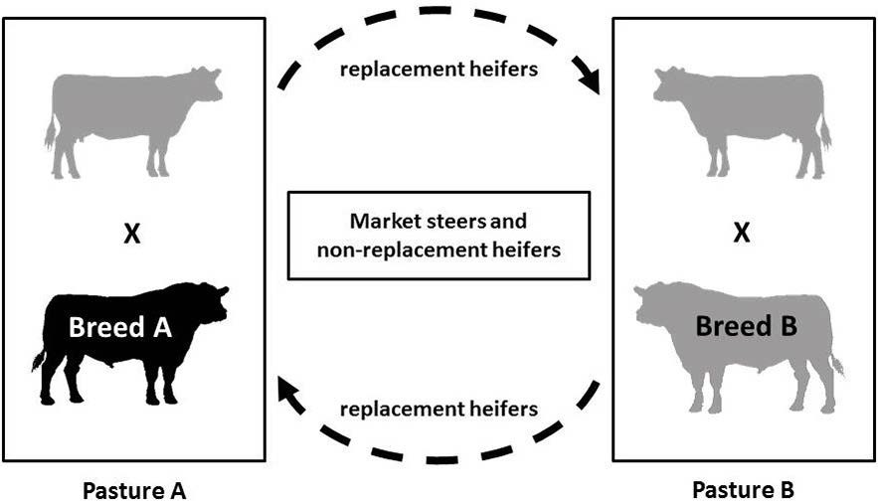
Figure 3. Two-breed rotational crossbreeding system

females sired by Breed C, and Breed C sires are mated to females sired by Breed A (Figure 4). Replacements are retained from within the herd, and three breeding pastures are needed.
The primary benefit of a three-breed rotation over a two-breed rotation is the increase in hybrid vigor. In a three-breed rotation, hybrid vigor stabilizes at 86 percent
of potential individual and maternal hybrid vigor, and a 20 percent increase in pounds of calf weaning weight per cow exposed over the average of the parent breeds is realized.
Disadvantages of the three-breed rotation are that an additional breeding pasture and breed of bull(s)
must be maintained. In addition, management and labor requirements increase because of the additional complexity of using three breeds over two. As in the two-breed rotation, the three breeds used should be complementary with maternal characteristics conducive to the breeding female’s role in a commercial herd.
Using the previous example of 25 females per sire with three breeds of sire, at least 75 breeding age females are needed to be efficient. The three-breed rotation can be used with fewer cows; however, bull expenses per cow will be greater. Lastly, the ability to locate three breeds that fit a given breeding scheme can be challenging and limit the ability to readily use three breeds.
Four-breed Rotation
The four-breed rotation is just like the other rotations, only with four breeds of sire utilized. Breed A sires are mated to females sired by Breed B, Breed B sires are mated to females sire by Breed C, Breed C sires are mated to females sired by Breed D, and Breed D sires are mated to females sired by Breed A. Replacements are retained from within the herd, four breeding pastures are used, and four breeds of sires must be maintained.
In a four-breed rotation, hybrid vigor stabilizes at 93 percent of potential individual and maternal hybrid vigor, and a 22 percent increase in pounds of calf weaning weight per cow exposed over the average of the parent breeds is observed. This is only a slight gain from the three-breed rotation with the added cost of labor, management, and another breed of sire. Depending upon the circumstances
of the operation, the benefits may not outweigh the cost in using a four-breed rotation in place of a three-breed rotation. Also, assuming 25 breeding-age females per
sire, at least 100 breeding-age females are needed for this system to be efficient.

Three-breed Rototerminal
A three-breed rototerminal system is an extension of the two-breed rotational system. It is also known as a two- breed rotation with terminal sire system. A percentage of
the breeding females are placed in the two-breed rotation, and another percentage is mated to a terminal sire (Figure
5). For example, 50 percent of herd females are in the two- breed rotation, and 50 percent are mated to a terminal sire of Breed T. The females in the two-breed rotation produce the replacement heifers, and the females in the terminal cross produce all market calves.
The rototerminal system is essentially a hybrid crossbreeding program using aspects of a terminal program and a rotational program. This system allows the breeder to produce all of his or her own replacements while making greater use of hybrid vigor in the terminal calves. Terminal sires can be selected for increased growth and carcass traits to maximize production from the cowherd. The breeds used in the two-breed rotation must still be selected for the criteria specified in the rotational programs. The downsides are that more labor,
management, and breeding pastures are needed than in a two-breed rotation.

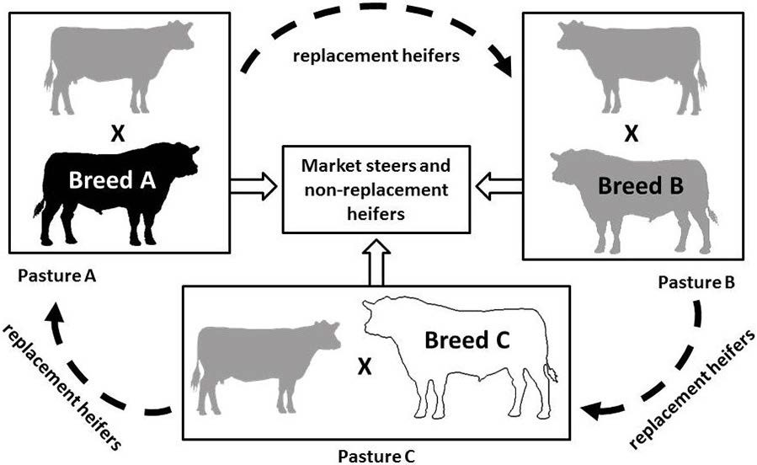

Figure 4. Three-breed rotational crossbreeding system.

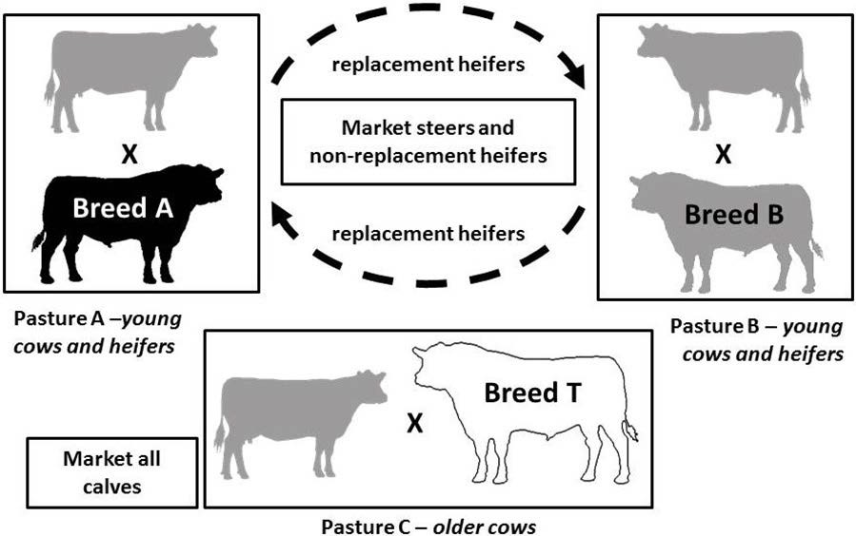

Figure 5. Three-breed rototerminal crossbreeding system.

Sire Rotation
Sire rotation is a common crossbreeding system. One breed of sire is used for 4 to 6 years, and then the sire breed is changed. This system can use two (Figure 6), three (Figure 7), or more breeds depending on the goals of the producer. This system is simple in that only one breeding pasture is used, and only one breed of sire is maintained.
A relatively high level of heterosis is maintained, usually
50 percent or greater depending on the number of sires used and the sequence in which sire breeds are used. Small producers often use this program because only one breed
of sire is needed at a time.
The biggest concern when using the sire rotation is inbreeding. If a sire’s daughters are retained as replacements, action needs to be taken to prevent inbreeding. This often means replacing the herd sire or adding breeding pastures and separating females from their sires.
Table 1 provides a summary of beef cattle crossbreeding system details and considerations. Implementing a well-designed crossbreeding system is an important management practice for improving profitability on commercial cattle operations. Such a system should be used to take advantage of breed complementarity and heterosis while also fitting the herd size and resources of the operation. For more information about beef cattle production, contact your local MSU Extension office.

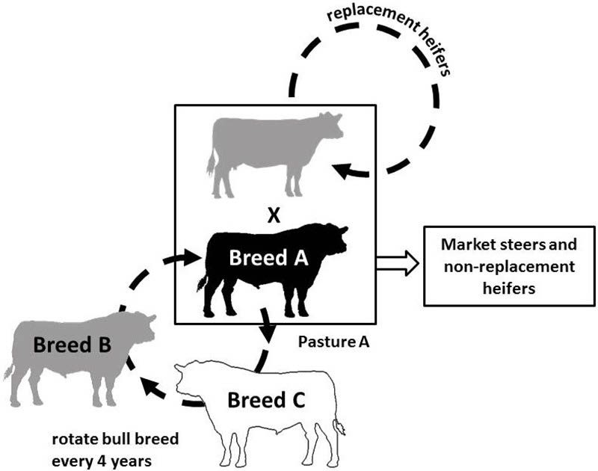
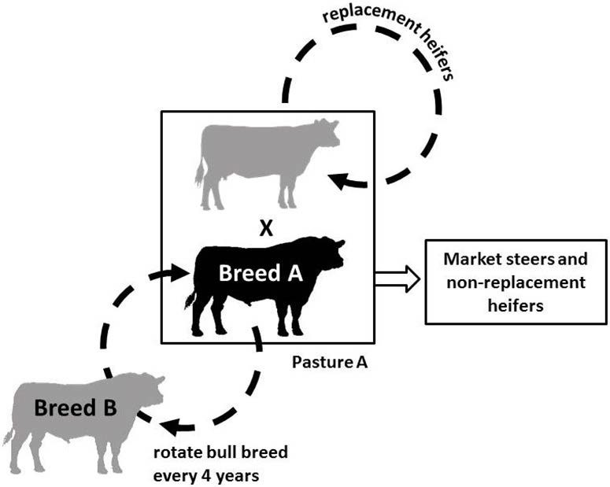

Figure 6. Sire rotation crossbreeding system using two breeds.

Figure 7. Sire rotation crossbreeding system using three breeds.

Figure 7. Sire rotation crossbreeding system using three breeds.

Table 1. Summary of beef cattle crossbreeding system details and considerations.
Breeding Program | Program Details | Considerations | Practical minimum size of cowherd
Two-breed Terminal | • 1 breeding pasture  • 1 sire breed  • Low labor requirement  • Uniform type progeny | • No maternal hybrid vigor  • Replacements purchased | Any size
Three-breed Terminal | • 1 breeding pasture  • 1 sire breed  • Low labor requirement  • Uniform type progeny  • Maximum hybrid vigor achieved | • Replacements purchased | Any size
Two-breed Rotation | • 2 breeding pastures  • 2 sire breeds  • Mid-level management  • Moderate maternal hybrid vigor  • Moderate individual hybrid vigor  • Replacement heifers retained | • Maternal/growth sire required  • Additional labor  • Additional management  • Female and sire ID crucial | >50 head
Three-breed Rotation | • 3 breeding pastures  • 3 sire breeds  • Mid-level management  • High maternal hybrid vigor  • Higher individual hybrid vigor  • Replacement heifers retained | • Maternal/growth sires required  • Additional labor  • Additional management  • Female and sire ID crucial | >75 head
Four-breed Rotation | • 4 breeding pastures  • 4 sire breeds  • High-level management  • High maternal hybrid vigor  • High individual hybrid vigor  • Replacement heifers retained | • Maternal/growth sires required  • Additional management  • Female and sire ID crucial | >100 head
Rototerminal | • 3 breeding pastures  • 2 sire breed (rotation) + 1 sire breed (terminal)  • High-level management  • High maternal hybrid vigor  • High individual hybrid vigor  • Replacement heifers retained | • Maternal sires and terminal sires needed  • High-level management  • Female and sire ID crucial | >100 head
Sire Rotation | • 1 breeding pasture  • 1 sire breed  • Low-level management  • Low labor requirement  • Moderate hybrid vigor  • Replacement heifers retained | • Avoids interbreeding | Any size

References
Gosey, J. A. 1991. Crossbreeding Systems and the Theory
Behind Composite Breeds. Univ. Nebraska, Lincoln, NE. Accessed online at http://digitalcommons.unl.edu/ cgi/viewcontent.cgi?article=1235&context=rangebeefc owsymp on December 3, 2012.
National Beef Cattle Evaluation Consortium. 2010. Beef Sire Selection Manual. 2nd ed. Iowa State Univ., Ames, IA.

The information given here is for educational purposes only. References to commercial products, trade names, or suppliers are made with the under- standing that no endorsement is implied and that no discrimination against other products or suppliers is intended.

Publication 2755 (POD-02-19)

Reviewed by Brandi Karisch, PhD, Associate Extension/Research Professor, Animal and Dairy Science. Originally written by Samuel Plank, former Graduate Research Assistant, Animal and Dairy Sciences; Jane Parish, PhD, Professor and Head, North Mississippi Research and Extension Center; and Trent Smith, PhD, Associate Professor, Animal and Dairy Sciences.


Copyright 2019 by Mississippi State University. All rights reserved. This publication may be copied and distributed without alteration for nonprofit educational purposes provided that credit is given to the Mississippi State University Extension Service.
Produced by Agricultural Communications.
Mississippi State University is an equal opportunity institution. Discrimination in university employment, programs, or activities based on race, color, ethnicity, sex, pregnancy, religion, national origin, disability, age, sexual orientation, genetic information, status as a U.S. veteran, or any other status protected by applicable law is prohibited. Questions about equal opportunity programs or compliance should be directed to the Office of Compliance and Integrity, 56 Morgan Avenue, P.O. 6044, Mississippi State, MS 39762, (662) 325-5839.
Extension Service of Mississippi State University, cooperating with U.S. Department of Agriculture. Published in furtherance of Acts of Congress, May 8 and June 30, 1914. GARY B. JACKSON, Director

